**Valle-Inclán, Ramón María del (1866-1936)**

The Spanish dramatist, novelist, and poet Ramón del Valle-Inclán was a major figure of the Generation of 1898, a group of writers that reinvigorated Spanish letters in the wake of the Spanish-American War of 1898, which marked the end of Spain’s colonial empire. Valle-Inclán was one of the most radical dramatists of the early twentieth century and worked to subvert the traditionalism of Spanish drama. Influenced by French modernism and Symbolism, he later moved to more experimental styles and is known for the creation of the ESPERPENTO, an absurd and grotesquely satirical mix of comedy and tragedy. This style expresses the tragic meaning of Spanish life, which Valle considered to be a “grotesque deformation” of European civilization. He held several administrative and teaching appointments, which allowed him to dedicate his life to writing while providing for his wife and five children.

|  |  |
| --- | --- |
| Born and raised in rural Galicia, Valle-Inclán traveled to Mexico and Cuba and finally settled in Madrid, where he drew attention with his extravagant appearance and flamboyant personality. His feisty character eventually cost him his left arm, lost due to an infection caused by a wound acquired in an argument. His extremely slender figure, long grey beard, dark clothing, and round thick glasses rendered him a strange character in Madrid’s coffee shops and their bohemian literary gatherings, or *tertulias*. |  |

Valle-Inclán’s native Galicia and Symbolist influences feature in his first notable works, four novels called *Sonatas* (1902-1905). They parallel the four seasons and narrate the decadent, seductive life of a womanizer who is partly an alter ego of the author. Some of Valle-Inclán’s later plays and novels are written in the manner he called “esperpento”. This intentionally absurd, satirical style is intended to express the tragic meaning of Spanish life through the distortion of classic heroes. The best of his *esperpento* plays are *Luces de Bohemia* (1920) [*Bohemian Lights*], which chronicles the last day in the life of a blind poet in a decaying Madrid, and *Los cuernos de Don Friolera* [*Don Friolera’s Horns*] (1921),,which dramatizes a love triangle between a cowardly lieutenant, his wife and a barber, and the subsequent revenge of the lieutenant. Valle-Inclán’s plays often feature special effects and cinematic-like changes of scene, which rendered their commercial production difficult during his lifetime.

His major novels of the later period include three works, *La corte de los milagros* (1927), *Viva mi dueño* (1928), and *Baza de espadas* (1932), which were part of an unfinished nine-volume cycle of historical novels collectively entitled *El ruedo ibérico* (1927–28; “The Iberian Circle”); the completed works deal with the political corruption and social degradation of Spain in the latter nineteenth century, from the reign of Queen Isabella II to the Spanish-American war of 1898. The novel *Tirano Banderas* (1926) is a vivid portrayal of a Latin-American despot.

Valle-Inclán is a crucial yet controversial figure in Spanish modernist letters. A defender of the Carlist cause (traditional absolutism), he fought to gain nobility titles, at the same time publicly condemning Primo de Rivera’s dictatorship and thus having to spend several days in prison. He died of a malignant cystic infection at the age of 69 back in Galicia, where he was already a patient of a radiotherapy clinic.

**List of key works:**

**Plays**

(1920) *Divinas palabras*

(1920, 1924) *Luces de bohemia [Bohemian Lights]*

(1927) *Retablo de la avaricia, la lujuria y la muerte*

(1930) *Martes de Carnaval*

**Narrative**

(1902-05) *Sonatas (de otoño, de estío, de primavera, de invierno*)

(1926) *Tirano Banderas*

(1927-58) *El ruedo ibérico*

**Poetry**

(1919) *La pipa de kif*

**References and further reading**

Lyon, J. (1983) *The Theatre of Valle-Inclán*, Cambridge: Cambridge U. Press

Dougherty, D. (1986) *Valle-Inclán y la Segunda República,* Valencia: Pre-textos

Flynn, G. C. (1994) *The Aesthetic Code of Don Ramón del Valle-Inclán*, Huntington, W. Va.: University Editions.

Dougherty, D. (2003) *Palimpsestos al cubo: prácticas discursivas de Valle-Inclán*, Madrid: Editorial Fundamentos.

Frost, A. (2010) *The Galician Works of Ramón del Valle-Inclán: Patterns of Repetition and Continuity*, Oxford: Peter Lang.

**Iulia Sprinceana, Centre College (Kentucky)**

**IMAGES**

Picture URL: <http://www.elpasajero.com/vipzuloaga.html>

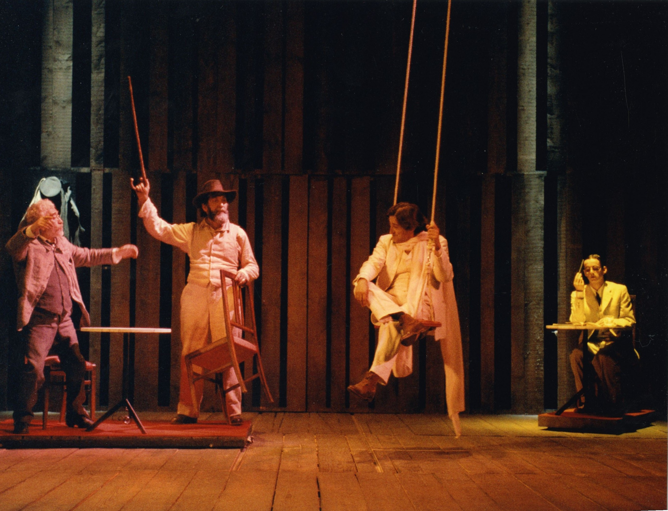

The setting for the 9th scene of *Luces de bohemia,* 2003, directed by Helena Pimenta. Copyright Helena Pimenta. In this scene Max Estrella, the protagonist, meets Modernist poet Rubén Darío (in the swing) at the Café Colón. The lighting of this staging reflects the bohemian ambient of the era and directly reflects the title of the play.

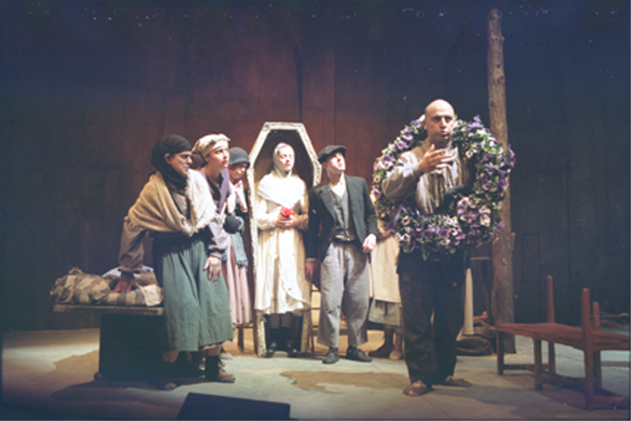

The setting for the final scene of *La rosa de papel.* Copyright: Centro de Documentación Teatral, Madrid (CDT). Photo from the 1995 staging by José Luis Gómez. Following the death of his wife, and upon locating the money that she had been saving, the husband throws himself passionately over her dead body.